TASK1

#include <unistd.h>
#include <sys/types.h>
#include <sys/wait.h>
#include <stdio.h>
#include <errno.h>
#include <stdlib.h>

int main ( ) {
int childpid = fork ( ) ;
if ( childpid == 0 ) {
printf (" I am a child proce with pid = %d \n" , getpid ( ) ) ;
printf (" The next statement is execl and execExam executable will run \n" ) ;
execl ("/bin/ls","ls","-l","/usr",NULL) ;
printf( " Execl failed " ) ;
}
else if( childpid > 0 ) {
wait (NULL) ;
printf ( "\n I am parent process with pid = %d and finished waiting \n" , getpid ( ) ) ;
}
return 0 ;
}
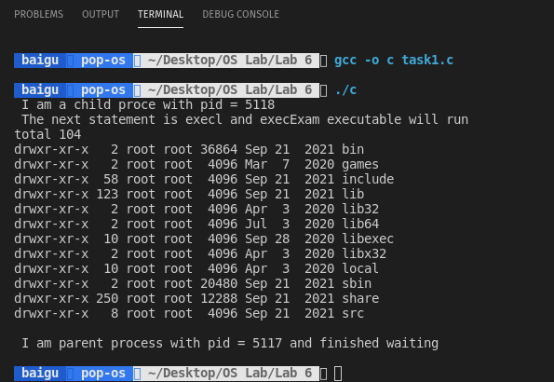
TASK2
#include <unistd.h>
#include <sys/types.h>
#include <sys/wait.h>
#include <stdio.h>
#include <errno.h>
#include <stdlib.h>

int main ( ) {
printf("hello\n");
char buff1[20];
char buff2[20];
char buff3[20];

printf("Enter the path of the command: ");
scanf("%s",buff1);
printf("\n");
printf("Enter command: ");
scanf("%s",buff2);
printf("\n");
printf("Enter secondary command: ");
scanf("%s",buff3);
printf("\n");

execl(buff1,buff2,buff3,NULL);

printf("hello after exec()/n");

return 0 ;
}
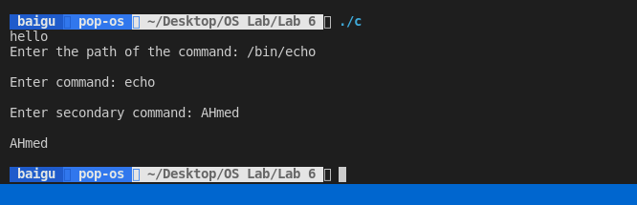
TASK3
#include <unistd.h>
#include <sys/types.h>
#include <sys/wait.h>
#include <stdio.h>
#include <errno.h>
#include <stdlib.h>

int main(){
char str[50];
char str2[50];
char str3[50];
printf("enter path\n");
scanf("%s",&str);
printf("enter command\n");
scanf("%s",&str2);
printf("enter command\n");
scanf("%s",&str3);
int childpid = fork ( ) ;
if(childpid==0){
printf("this is child proc with id %d ",getpid());
execlp(str,str2,str3,NULL);
printf("exec failed\n");
}else{
wait(NULL);
printf("this is parent proc with id ", getpid());
}
return 0;
}
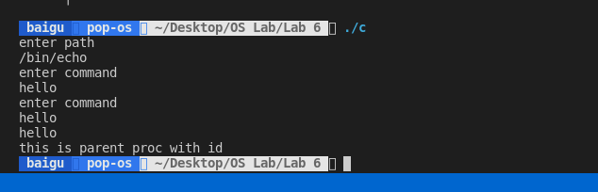
TASK4
#include <unistd.h>
#include <sys/types.h>
#include <sys/wait.h>
#include <stdio.h>
#include <errno.h>
#include <stdlib.h>

int main(){
int childpid = fork ( ) ;
if(childpid==0){
printf("this is child proc with id %d ",getpid());
char* argv[]={"ls","-1","/usr",NULL};
execv("/bin/ls",argv);
printf("exec failed\n");
}else{
wait(NULL);
printf("this is parent proc with id ", getpid());
}
return 0;
}

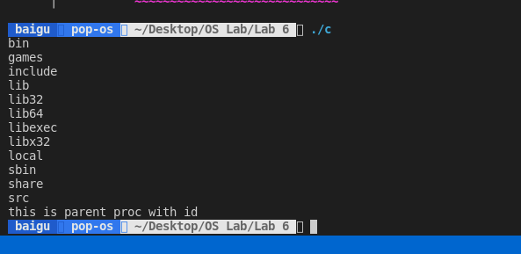
TASK5
#include <unistd.h>
#include <sys/types.h>
#include <sys/wait.h>
#include <stdio.h>
#include <errno.h>
#include <stdlib.h>

int main(){
int childpid = fork ( ) ;
if(childpid==0){
printf("this is child proc with id %d ",getpid());
char* argv[]={"ls","-1","/usr",NULL};
execvp("ls",argv);
printf("exec failed\n");
}else{
wait(NULL);
printf("this is parent proc with id ", getpid());
}
return 0;
}

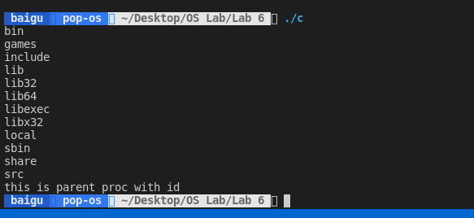
TASK6
#include <unistd.h>
#include <sys/types.h>
#include <sys/wait.h>
#include <stdio.h>
#include <errno.h>
#include <stdlib.h>

int main(){
int childpid = fork ( ) ;
if(childpid==0){
printf("this is child proc with id %d ",getpid());
char* argv[]={"ls","-1","/usr",NULL};
char* env[] = {"export TERM=vt 100","PATH=/bin:/usr/bin",NULL};
execle("/bin/cat","cat","f1",NULL,env);
printf("exec failed\n");
}else{
wait(NULL);
printf("this is parent proc with id ", getpid());
}
return 0;
}

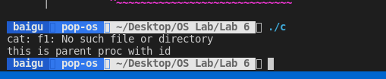
TASK7
#include <unistd.h>
#include <sys/types.h>
#include <sys/wait.h>
#include <stdio.h>
#include <errno.h>
#include <stdlib.h>

int main(){
int childpid = fork ( ) ;
if(childpid==0){
printf("this is child proc with id %d ",getpid());
char* env[]={"export TERM=vt 100","PATH=/bin:/usr/bin",NULL};
char* args[]={"cat","f1",NULL};
execve("/bin/cat",args,env);
printf("exec failed\n");
}else{
wait(NULL);
printf("this is parent proc with id ", getpid());
}
return 0;
}

